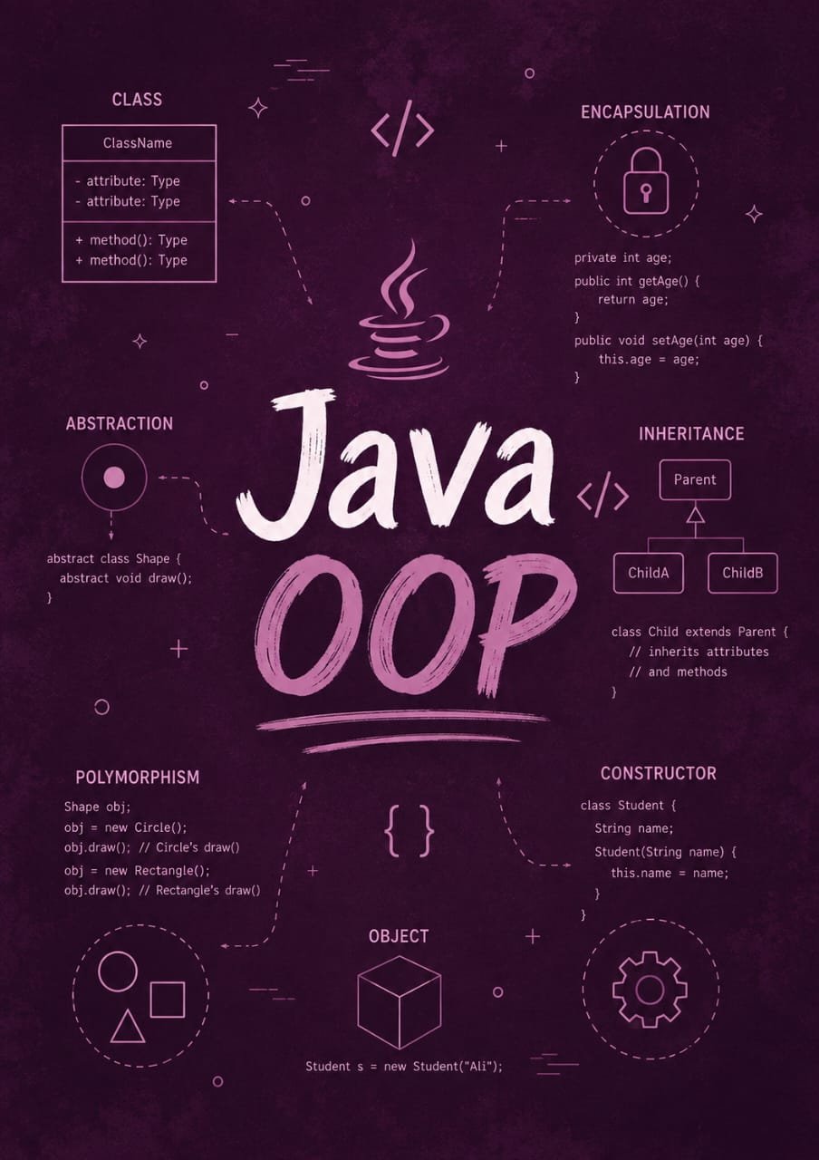

Java Fundamentals

By Jawad Jammoul

